Introduction:

This document help end users a great deal in understanding and working with the system once it has been implemented. This guide allows for teaching end user how to actually use the system. The system has many features that offer help in daily processes of the hotel. Here is a list of all the features that the system has with detailed description for each and screenshots of the relevant screens have been provided.

1. Login
2. Guests
3. Reservations
4. Check-in
5. Check-out
6. Inventory
7. Employees
8. Rooms
9. Room Type
10. Menu
11. Log-Out
12. Login

The first screen that shows up as soon as the system starts to execute is the login. User of the system can enter the default login username that is “user1” and password that is “3674pk” and then clicking the Login Button to log into the system. The login screen can be seen in the diagram given below.

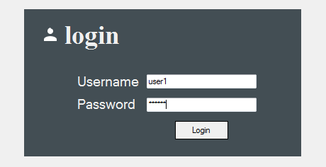

Diagram: User login screen

1. Guests

As soon as the user logins to the system, the main screen of the system shows up. The landing screen of the system that opens by default is the Guest Management screen of the system. Here the user can see the guests that are either of expected or currently staying at the hotel.

To add a new guest, enter the details of the guests in the fields below the guest’s DataGridView. Then click the “Add Guest” Button which can be been in the diagram below. As soon as the user clicks the button, new guest record will be added into the system.

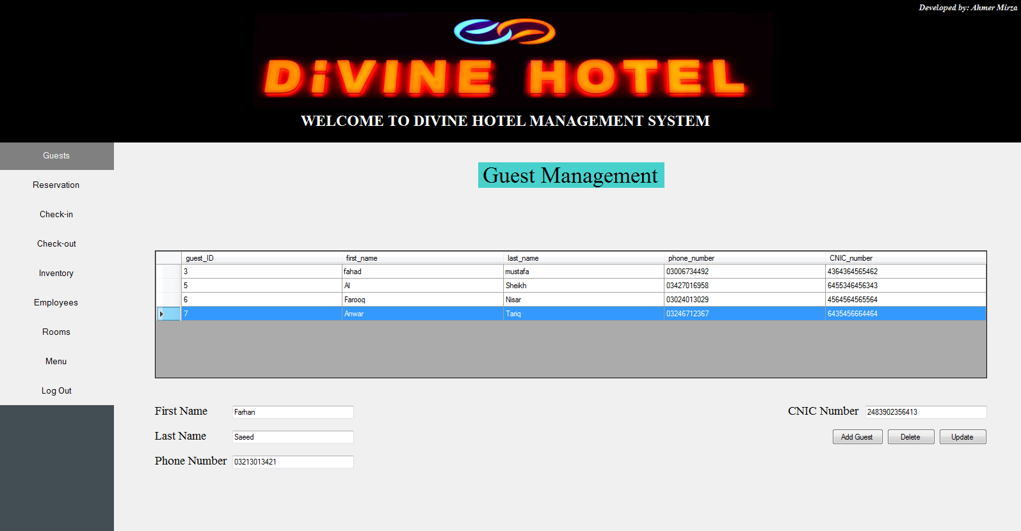

Diagram: Main Screen showing Guesting Management feature of the system

To delete a guest, select the guest that you want to delete and then click the “Delete” button shown in the diagram given below.

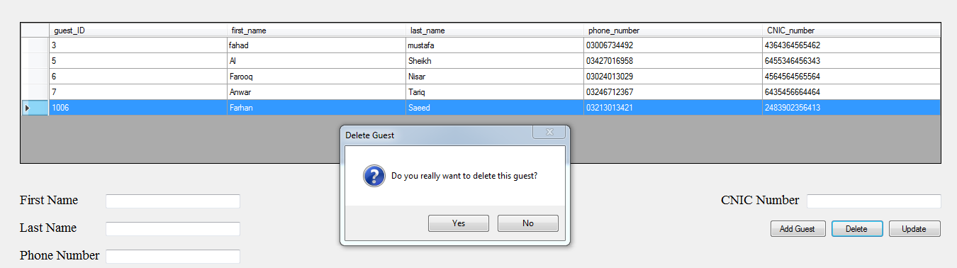

Diagram: Deleting a guest

To update a guest details, double click on the guest record from the DataGridView that you want to update details for. Guest’s details will appear in their corresponding fields which can be seen in diagram below.

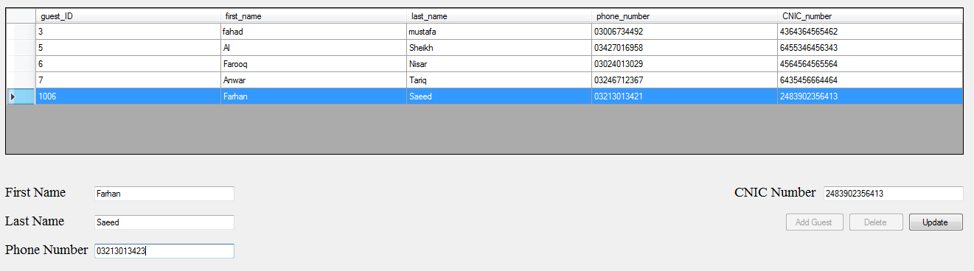

Diagram: Updating guest details

Make changes that you want to make to either of the details and then click the “Update” button. A message box acknowledging update is completed will be displayed as soon as the user click the “Update” button which can be seen in the diagram below.

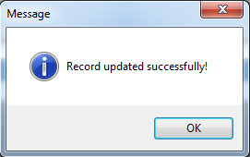

Diagram: Message box acknowledging completion of the updating process

1. Reservations

To go to Reservation Management screen, click the Reservations Button from the left hand side of the main screen. This will open the Reservation Management screen. From here user can add new reservations, delete reservations and update details for an existing reservation.

To add a new reservation, select a guest number from the Guest ID combo box that you want to make a reservation for and enter the reservation details in the fields below the reservations DataGridView. Then click the Add Reservation button as seen in the diagram below. As soon as the user clicks the Add Reservation button, new reservation will be added into the system.

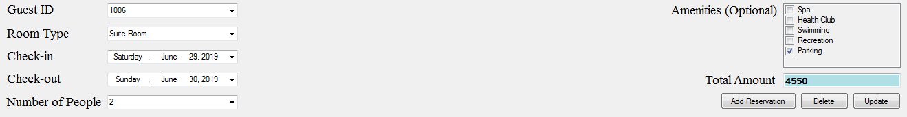

Diagram: Adding new reservation

To delete a reservation, select the reservation that you want to delete and then click the Delete button just like in the diagram given below.

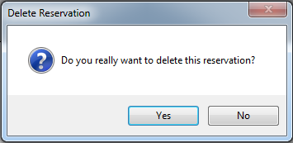

Diagram: Deleting a reservation

To update a reservation details, double click on the reservation from the DataGridView that you want to update details for. Reservation’s details will appears in their corresponding textboxes and controls which can be seen in diagram below.

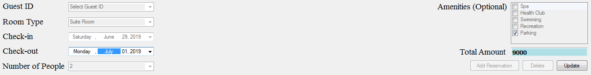

Diagram: Updating reservation details

Make changes that you want to make to either of the details and then click the Update button. A message box acknowledging update is completed will be displayed as soon as the user click the Update button which can be seen in the diagram below.



Diagram: Message box acknowledging completion of the updating process

1. Check-in

To go to Check-in Management screen, click the Check-in Button from the left hand side of the main screen. This will open the Check-in Management screen. From here user can make check-ins for a reservation.

To make a check-in, select a reservation number from the Reservation Number combo box that you want to make check-in for and select and enter remaining details in the fields below the check-in DataGridView. Then click the Check-in Button as seen in the diagram below. As soon as the user clicks the Check-in Button, new check-in will be made into the system and the guest will be able to move into his/her allotted room.



Diagram: Making a new checkin

1. Check-out

To go to Check-out Management screen, click the Check-out Button from the left hand side of the main screen. This will open the Check-out Management screen. From here user can make check-outs for any occupied room.

To make a check-out, select a room number from the Room Number combo box that you want to make check-out for and select and enter remaining details in the fields below the check-out DataGridView. Then click the Check-out Button as seen in the diagram below. As soon as the user clicks the Check-out Button, new check-out will be made into the system and the guest will be able to leave the hotel.

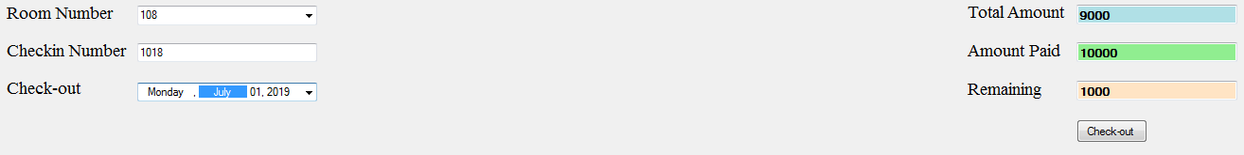

Diagram: Making a new checkout

1. Inventory

To go to Inventory Management screen, click the Inventory Button from the left hand side of the main screen. This will open the Inventory Management screen which can be seen in the diagram below. From here user can add new inventory, delete inventory and update details for an existing inventory by following the same steps as described for adding, deleting and updating a guest details. The Inventory Management screen can be seen in the diagram below.

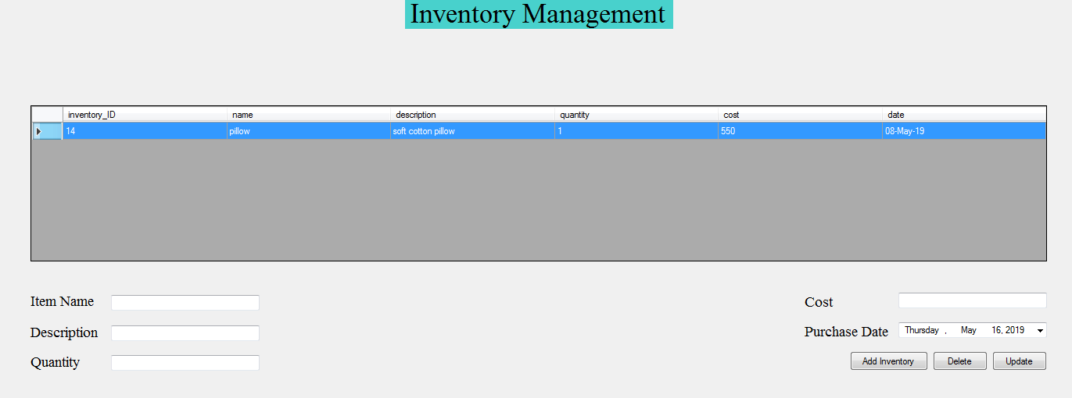

Diagram: Inventory Management feature of the system

1. Employees

To go to Employee Management screen, click the Employees Button from the left hand side of the main screen. This will open the Employee Management screen which can be seen in the diagram below. From here user can add new employee, delete employee and update details for an existing employee by following the same steps as described for adding, deleting and updating a guest details.

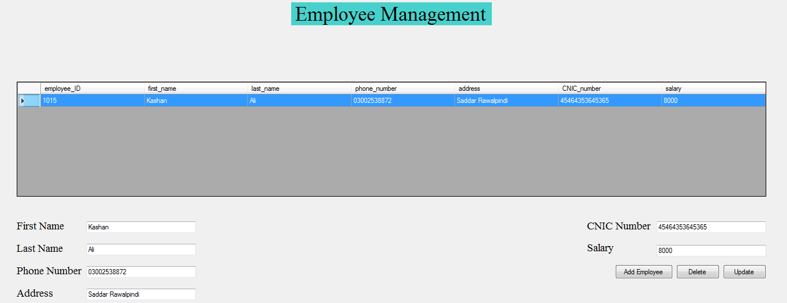

Diagram: Employee Management feature of the system

1. Rooms

To go to Room Management screen, click the Rooms Button from the left hand side of the main screen. This will open the Room Management screen which can be seen in the diagram below. From here user can add new rooms, delete rooms and update details for an existing room by following the same steps as described for adding, deleting and updating a guest details.

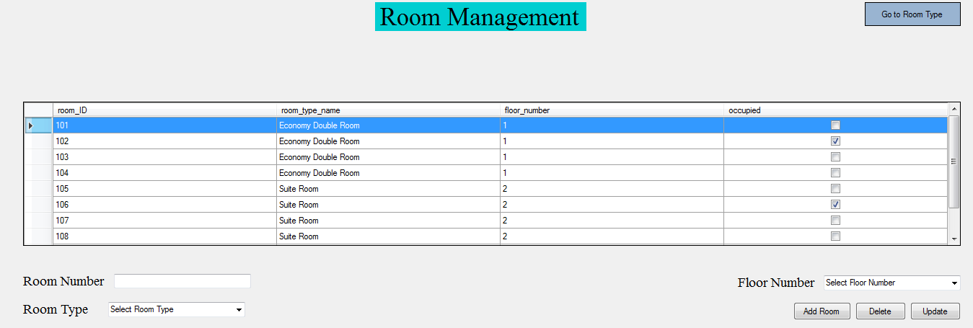

Diagram: Room Management feature of the system

1. Room Type

To go to Room Type Management screen, click the “Go to Room Type” Button on the right hand side of the Room management screen. This will open the “Room Type Management” screen which can be seen in the diagram below. From here user can add new room type, delete room type and update details for an existing room type by following the same steps as described for adding, deleting and updating a guest details.

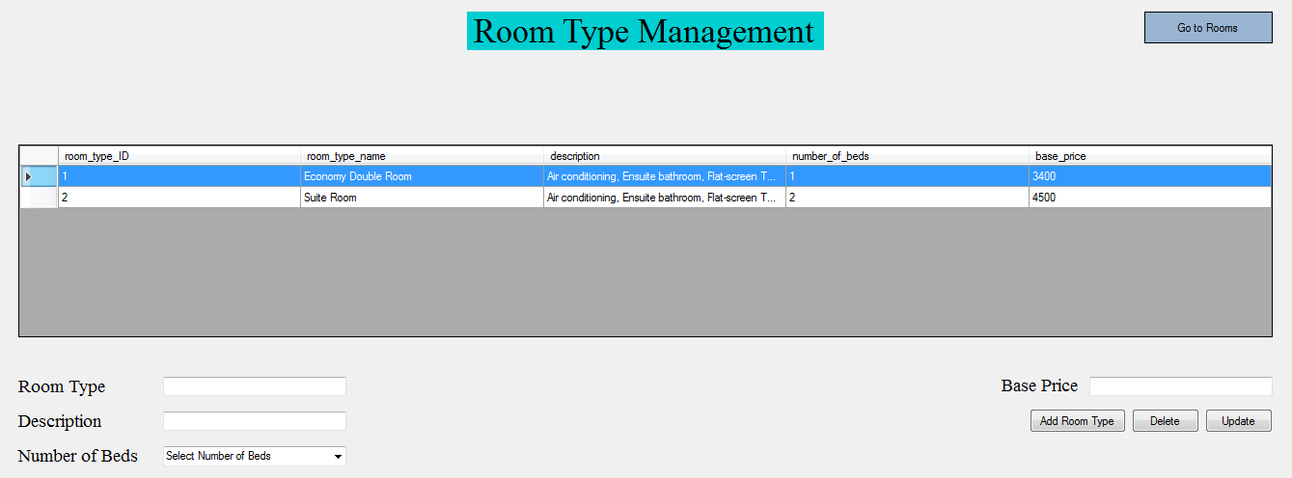

Diagram: Room Type Management feature of the system

1. Menu

To go to Menu Management screen, click the Menu Button from the left hand side of the main screen. This will open the Menu Management screen which can be seen in the diagram below. From here user can add new menu, delete menu and update details for an existing menu by following the same steps as described for adding, deleting and updating a guest details. This feature allows for keeping menu information up-to-date that is currently served at the hotel.

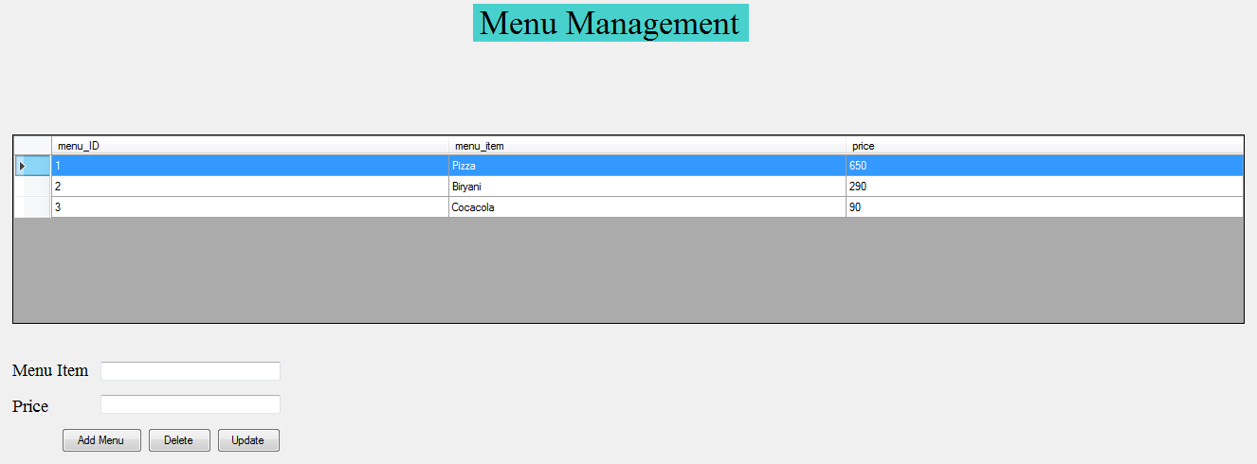

Diagram: Menu Management feature of the system

1. Log Out

To logout of the system and go back to the login screen, click the “Log Out” button on the left hand side of the main screen. This will open up the Logout Message box, shown in the diagram below, asking if the user really wants to logout of the system or not. Select “Yes” to log out of the system or “No” to keep working within the system. Once logged out, the user will be taken back to the login screen.

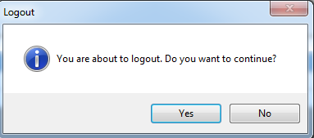

Diagram: Logout Message Box